Cheesy Baked Pasta With Sausage and Ricotta

11/15/2025— used lamb not pork (mistake, lamb crumbles too fine and doesn’t add distinct flavor). Added ½ pieces of mushrooms, mistake- was just kind of soggy. Added smaller pastas (lumache and Toscani)—mistake- came out a little chewy.

5/4/2025 – (generally make this about once every 1-2 months) – it’s the ricotta that breaks apart in the pasta! So went a little heavy on the mozzarella instead and came out well (used cheap WF mozzarella). Also spent a little more time browning the sausage, threw in a mix of spices since I didn’t have garlic (celery salt, oregano, bay leaves, red pepper, garlic powder). Came out well. Could use just a little more umami oomph…
1/30/2024
Still good – though Ayumi’s enthusiasm is waning. I think the buf moz is breaking apart in the sauce – could be the ricotta, but likely not. Go back to reg moz. 28 whole peeled and strained. Calamarata but added about 1.5 cups of water to keep them soaked, and had to leave in for a while. Broiler didn’t do it’s magic – too far away from broiler.
12/3/23
We love it! Got buffalo mozzarella - really good. Kept sausage chunks large and brown. 28 is whole peeled and strained. One cup water. Calamarata was good (but left in for an extra five minutes to cook pasta Al denté). Added parsley, meh, forgot basil.
6/19/23 – we all loved it. Broiler makes it amazing. We used calamarata, which had a longer cooking time. Ended up using 28 oz whole peeled, 28 oz strained. That was fine. Added 12 oz mozzarella. Added 2 cups water for pasta to help the cooking time, that was a mistake – came out delicious, but a tad soupy. Added cumin instead of fennel.
3/20/23 – kids loved it. Putting under broiler is awesome. We used lumache. Used pecorino, couldn’t really taste it. Needed more salt.

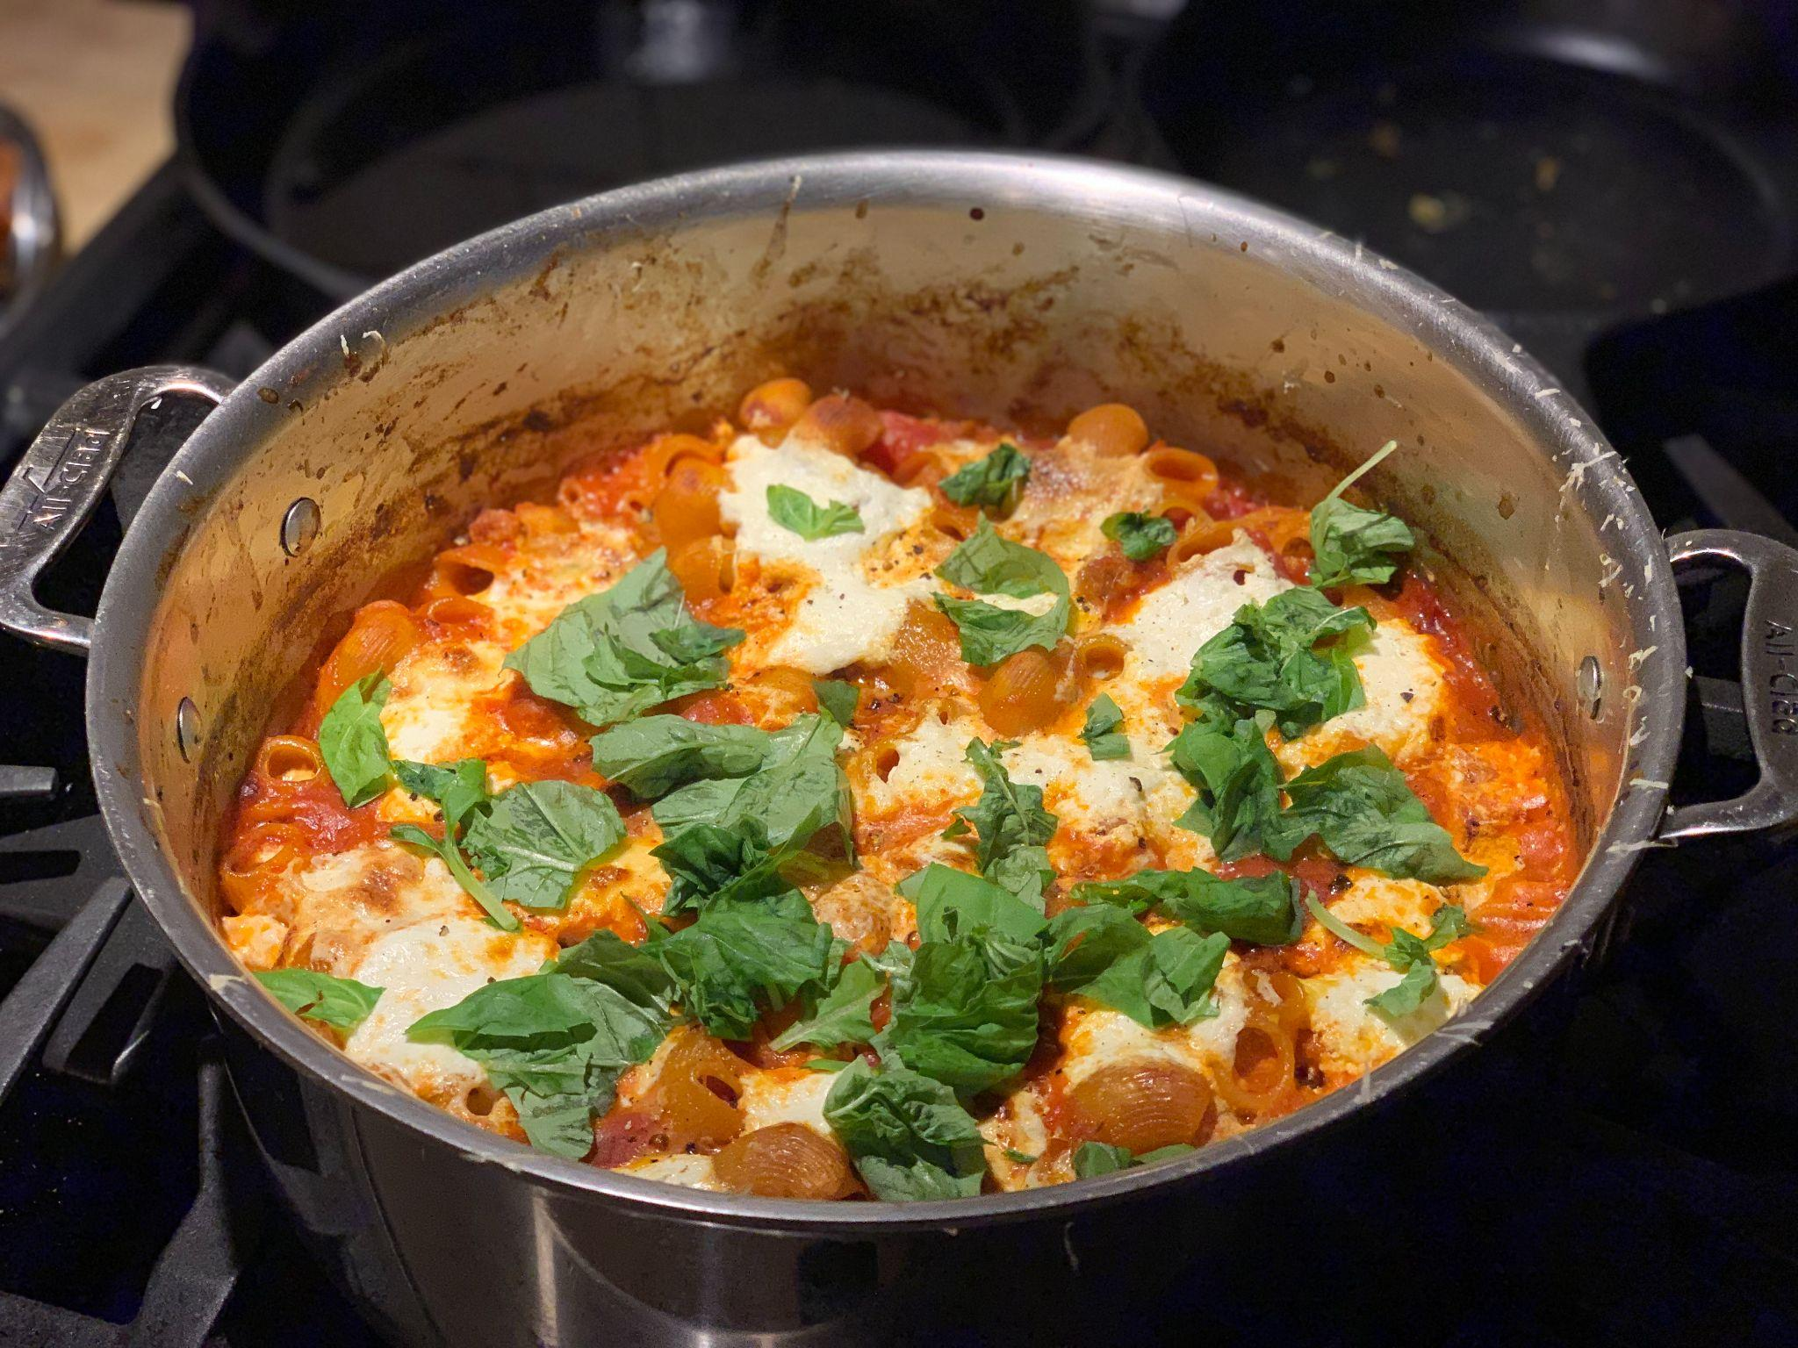
I’m
https://cooking.nytimes.com/recipes/1020811-cheesy-baked-pasta-with-sausage-and-ricotta

Serves about 6 people

- 3 tablespoons extra-virgin olive oil
- ¾pound bulk hot or mild Italian sausage (pork, chicken or turkey)
- 4 garlic cloves, thinly sliced
- 1 teaspoon dried oregano
- ½teaspoon fennel seeds, coarsely crushed
- Pinch of red-pepper flakes, plus more for serving (optional)
- 1(28-ounce) can whole peeled tomatoes with their juices
- 1(14-ounce) can crushed uor strained tomatoes
- 2 bay leaves
- Kosher salt
- 12 ounces dried pasta, such as small shells, farfalle or other shaped pasta
- 8 ounces fresh mozzarella, torn into bite-size pieces
- 6ounces whole-milk ricotta (about ¾ cup)
- ⅓cup grated Parmesan
- ¼cup basil leaves
- Black pepper, for serving

Step 1
Heat oven to 425 degrees. Heat oil in a 12-inch ovenproof skillet over medium-high. Crumble sausage into skillet, using a spoon to break it into small pieces. Cook until starting to brown, stirring occasionally, 5 to 7 minutes. Stir in garlic, oregano, fennel seeds and red-pepper flakes (if using), and cook another 1 to 2 minutes.

Step 2
Stir in whole tomatoes and their juice, using a spoon to break them up. Add crushed tomatoes, bay leaves and 2 teaspoons salt, and bring to a simmer. Simmer for 10 minutes to thicken slightly.

Step 3
Stir in pasta and 1 cup water and return to a simmer. Continue to simmer for 2 minutes, stirring frequently to make sure pasta doesn’t stick to the bottom of the pan. Remove from heat, pluck out the bay leaves, and fold in about a third of the mozzarella.

Step 4
Top pasta with remaining mozzarella and dollops of ricotta. Sprinkle with Parmesan, then transfer to oven. Bake until pasta is tender when poked with a fork, and cheese is bubbly and lightly golden, 18 to 22 minutes. (If you’d like a more deeply browned topping, run the pan under the broiler for 1 or 2 minutes.) Remove from oven and let cool slightly before serving. Top with basil, plenty of black pepper, and more red-pepper flakes, if you like.

